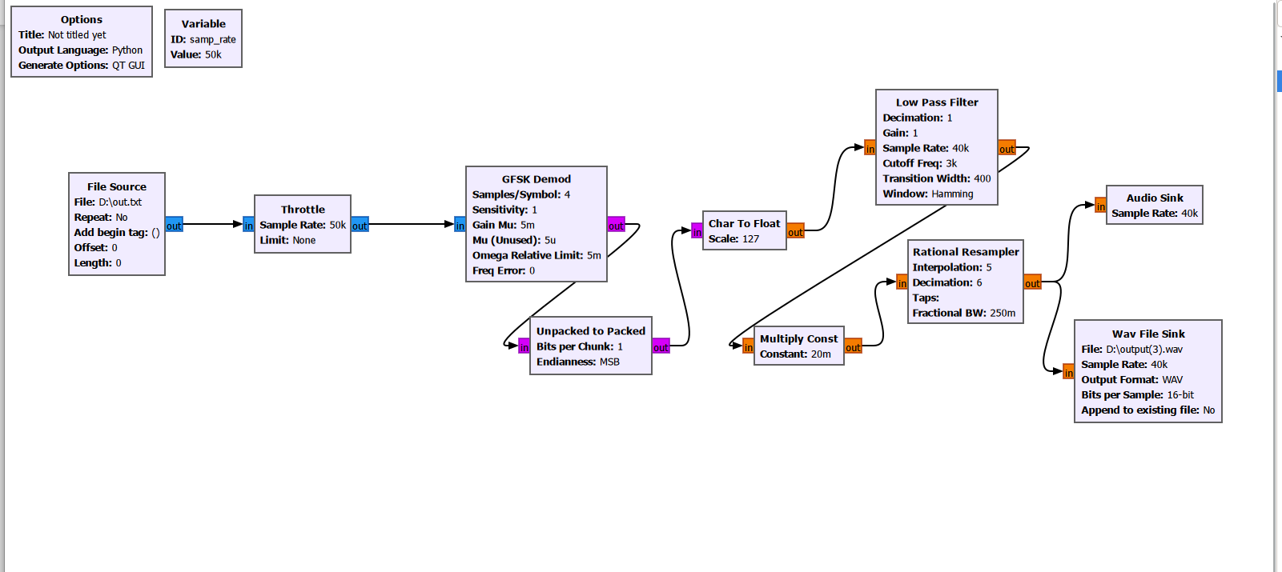

For the reverse process to recover the audio file,
- We start with the file source and input our out.txt file in complex datatype
- A Throttle block is used with a sample rate of 50 kHz to control the flow of samples and prevent the flowgraph from consuming excessive CPU resources.
- Gfsk demod performs demodulation and recovers the transmitted digital information from the modulated waveform.
- unpacked to packed block : used it after many hit and trials as Without this block, the subsequent audio processing stages operate on isolated bits rather than valid sample values, resulting in noise.
The Unpacked to Packed block groups every 8 bits into a byte, reconstructing the original byte stream that was transmitted as the demodulator outputs individual bits.
- Char to Float block so that it can be processed by audio-related blocks.
- then we use a low pass filter : To remove high-frequency components and noise present after demodulation.
- Multiply constant is used to adjust the signal amplitude by setting it to 1/50
- a rational resampler block is used
- The processed signal is sent to an Audio Sink for real-time playback
- Finally, the recovered audio is stored in a WAV file using a WAV File Sink, and I could hear a song.. the ouput is attached in the drive with name as “output(3).wav”
- and below I have attached my flowgraph.

